**ITIS 4250 / 5250**

**Praveen Nainar Balasubramanian**

**Student ID: 801231841**

**Lab #3**

**Overview:**

In this assignment, Dr. Robert Quincy asked me to get my new case from Mr.Det. Lansbury. Mr.Det. Lansbury handed over to me a file folder containing stolen property case details written up by officer Jimmy Johns of the UNCC POLICE department. Officer Johns checked an image of a thumb drive taken on consent from a subject which was investigated by him in the case. The file says someone has been involved in stealing Apple products from the University, including Macbooks, iMacs, and Mac Minis.

A thief has repeatedly stolen computer equipment from classrooms and buildings at the University of North Carolina at Charlotte. Particular items stolen include Apple computers, Apple TVs, iPads, and iPhones. Officer Johns noticed a shifty-looking individual around Woodward Hall on February 23rd of 2016. Several people pointed this individual out to Officer Johns, including Professor Lloyd Chudley Alexander, student Willie Mayes Hayes, and the Janitor, old Mr. McFarlane or Seth as everyone calls him. Woodward hall is one of the buildings where items have gone missing or reported stolen.

Officer Johns provided me with a forensic image he made of the subject’s thumb drive, which was provided on consent after the officer stopped him on his bike. The subject also had an iPhone 6s in his pocket which he did not provide. His backpack contained several iPads, a Mac Mini with a sticker scraped off, and an Apple laptop computer which Officer Johns seized later with a warrant.

# Forensic Acquisition & Exam Preparation

The environment utilized for this analysis is a Dell Inspiron 15 5000 computer with 16 GB of RAM and using Windows 10 Home. For this analysis, the software required is Autopsy 4.19.1. The file “ItemA_thumbdrive.E01” needs to be examined. I created a new case in Autopsy by using the given image file. Then, under the Analysis results, I found the answers to the questions asked by Det. Lansbury.

1. Software and system used:

FTK Imager

Autopsy

**Verification of image Thumb drive:**

**Findings and Report (Forensic Analysis)**

**a. You should provide any photographs relevant to the investigation.**

**i. Photographs of Apple devices.**

An Apple computer was found with the image under User Content Suspected in Analysis Results. The path of the file is /img_ItemA_thumbdrive.E01/vol_vol2//$CarvedFiles with file name f0017286.jpg.

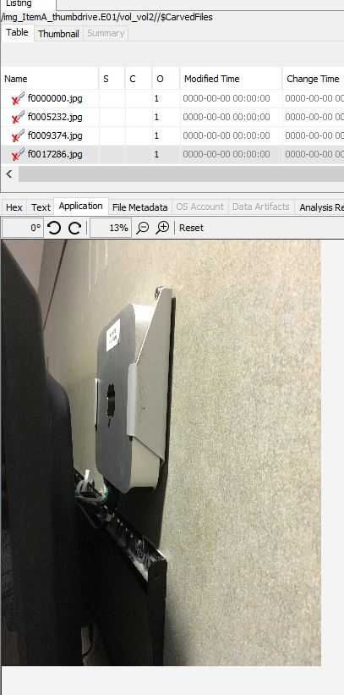

1. **Location information of those devices.**

The location information of the Apple Computer is found in the EXIF Metadata under Data Analysis. The latitude, longitude, and altitudes identified are 35.30714444444444, -80.7363888888889, and 205.93290734824282 respectively. By using Google Maps, I found the location as University City South, Charlotte, NC, 28027.

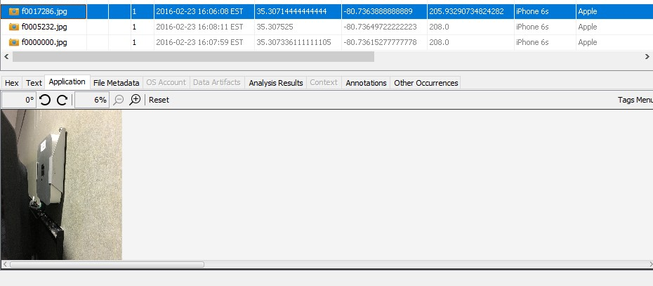

Analysis Report of the device along with its latitude and longitude:

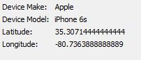

After entering Lat and Long value in Google map we obtain the location, we discover the image and identity that it has been taken in UNCC Woodward Hall(CCI).

We use the google map to find the exact location of latitude and longitude.

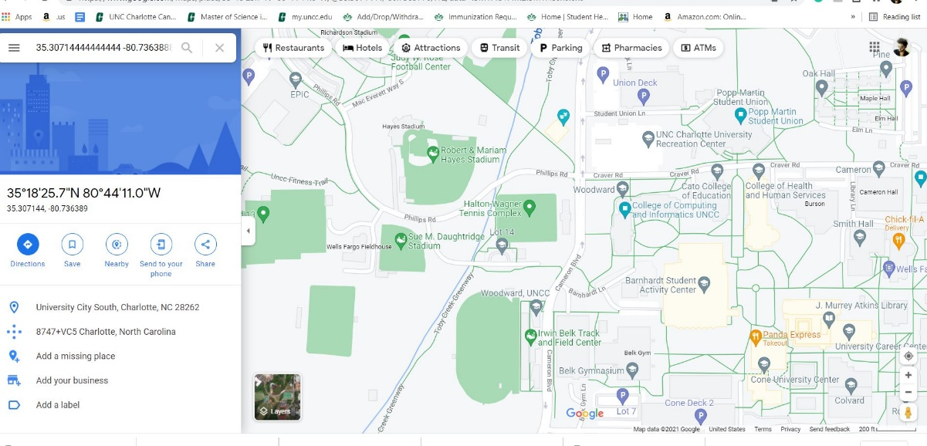

1. **Make/model of the camera device used to make the photos.**

The make of the camera device used to make the photos is Apple and the model is the iPhone 6s. This Finding is found under the Analysis results tab for the file f0017286.jpg.

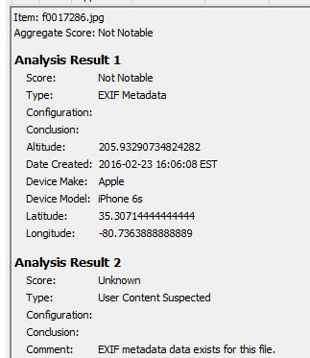

1. **Any content in the picture that might help identify the device.**

We identify a department identity tag of laptop number attached; the tag represents “Biology Dept **Tag#674**” which is pasted to the Apple Computer.

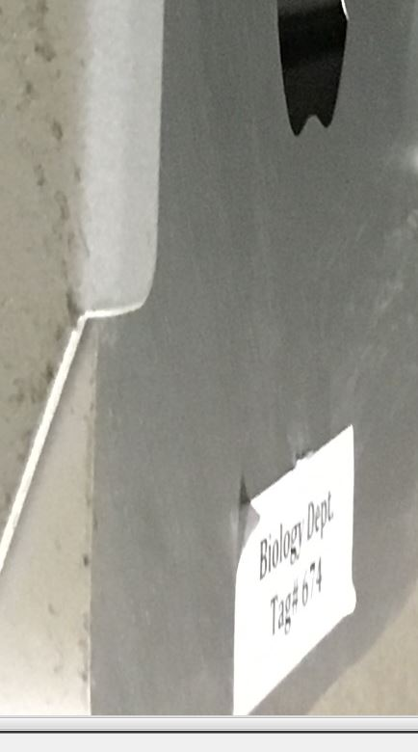

1. **Any content in the pictures whose content might be relevant to the theft of Apple devices.**

There are other devices apart from Apple devices which are the property of The University of North Carolina at Charlotte. The content in the picture represents the stolen apple devices from the university of north Carolina at charlotte.

The files _MG_1692.JPG, _MG_1693.JPG,_MG_1694.JPG all resembles the same longitude and Latitude which in turn give the impression that all devices in university and the picture are taken with the same iPhone 6 device.

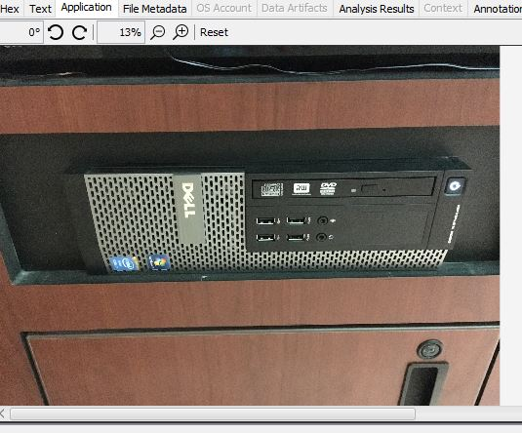

1. A computer running Windows 7 Enterprise and the screen contains the UNCC logo and a notice describing the university information technology use of a computer.

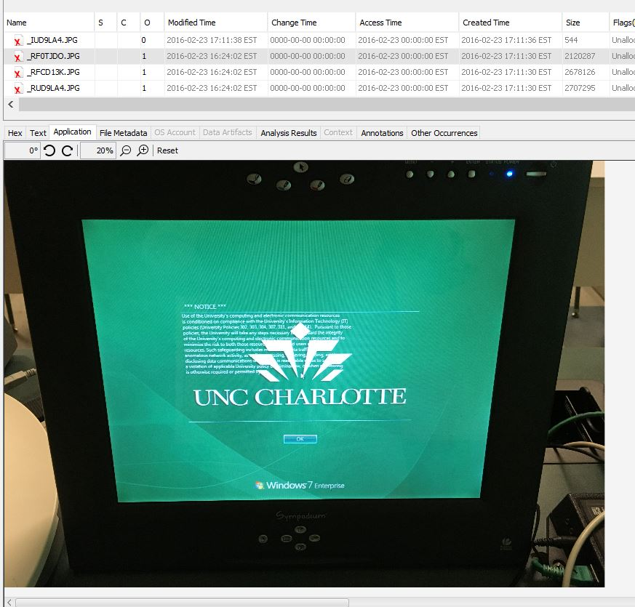

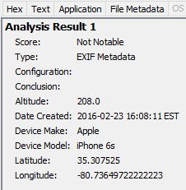

A printer is identified containing the machine number and UNCC information on it.

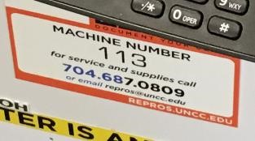

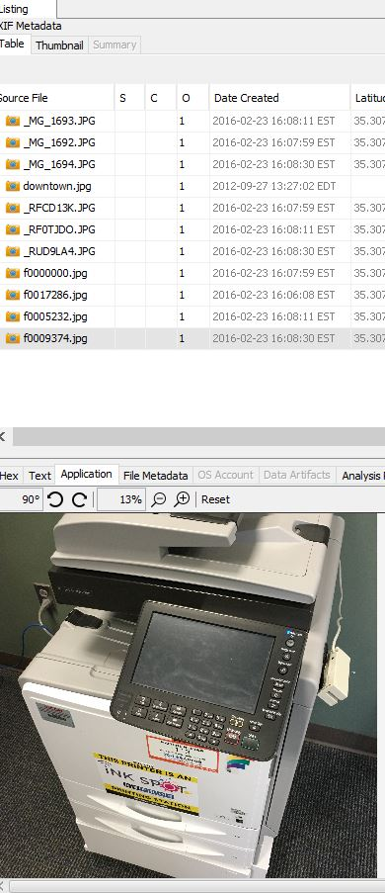

1. A Dell CPU with no identifications on it that it belongs to UNCC.

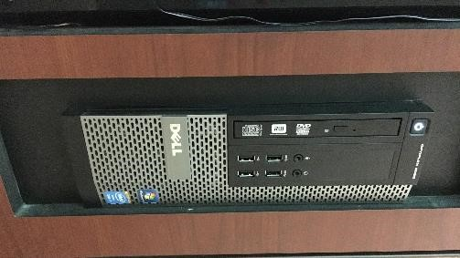

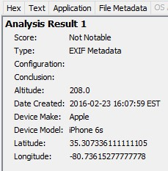

All the images above contain the same location information as University City South, Charlotte, NC, 28027.

**Conclusion:**

With reference, we confirm the completion of the analysis of the image provided by Det. Lansbury, The image was captured using an Apple iPhone 6s with the location information as University City South, Charlotte, NC, 28027. A Computer with the UNCC logo on the screen was identified in the case along with a printer containing UNCC information on the sticker, and a Dell CPU. All these devices also have the same location information as shown using the latitude and longitude information that was identified, An Apple Computer with a paper stuck on it written “Biology Dept Tag #674”. we found that the photos were taken near the Woodward Hall building in the University of North Carolina at Charlotte